**Lab 2 – Inverter Characteristics and the Ring Oscillator**

Faizan Bangash

TA : Saurav Kumar Sahu

ECEN 248 – 302

June 14th, 2018.

**Objectives –**

In this lab, I learned how NOT gates function. First, I focused on the voltage change of a single inverter, and then used an odd number of inverters to create a ring oscillator. I learned how inverters take some time to invert the signal proving that there are real trade­offs between a processor’s speed and accuracy. I also learned when an odd number of inverters are connected to make a ring oscillator.

**Design –**

In this lab, I used a TI 7404 board that inverts the signal sent to the inputs. The diagram below shows what a 7404 Inverter looks like.

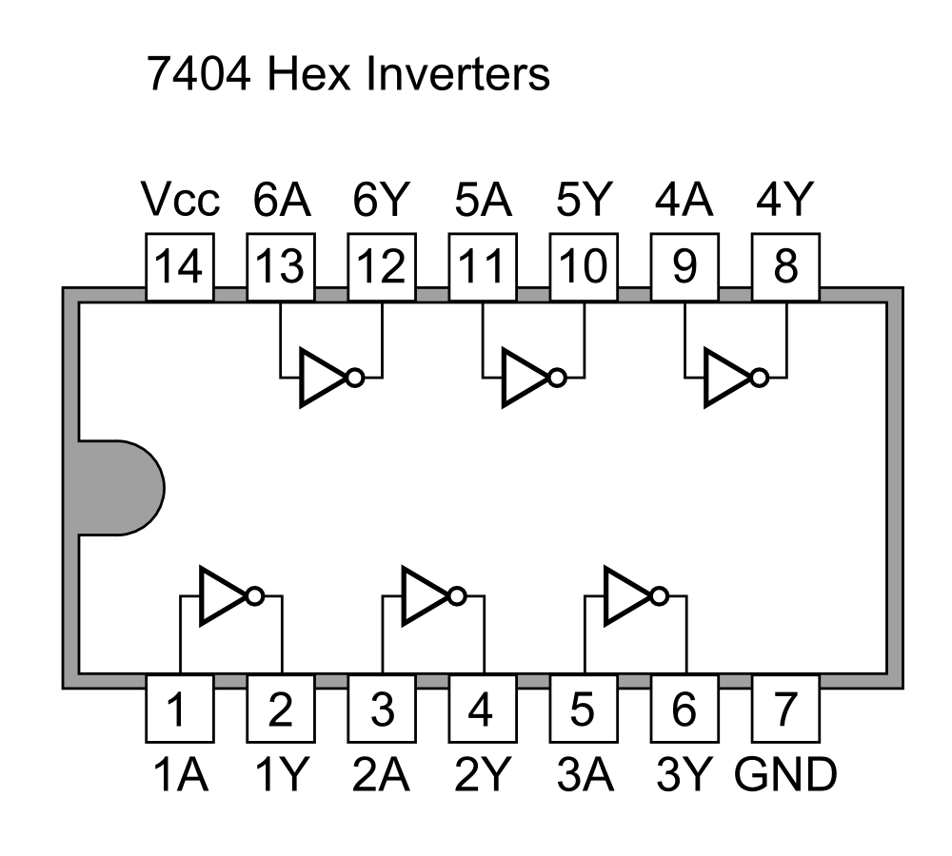

In the first part of the lab, I connected a 20 V supply to the Vcc pin, the ground supply to the GND pin, and a 5 V input to the 1A pin. After that I measured the output at 1Y using multiple different inputs at 1A ranging from 0 V to about 5 V.

For the second part of the lab, I connect an odd number of inverters to observe the behavior of a ring oscillator. The diagram of the gates can be seen below:

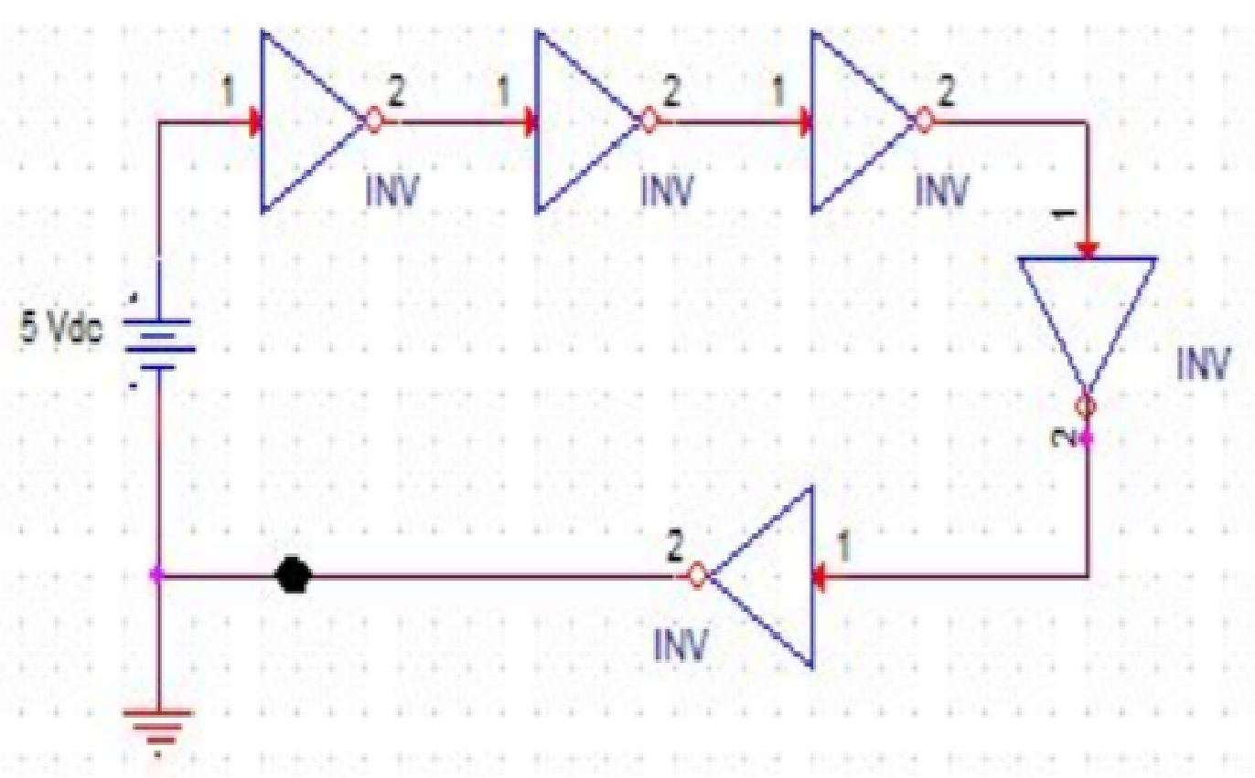

I then checked the current using the oscilloscope and graphed it in our results.

**Results –**

I first measured the voltage output vs. the voltage input. Initially there was not an immediate drop but a slow drop at first, followed by a rapid drop, then it smoothed out to a value near 0 Volts. As it can be seen in graph below:

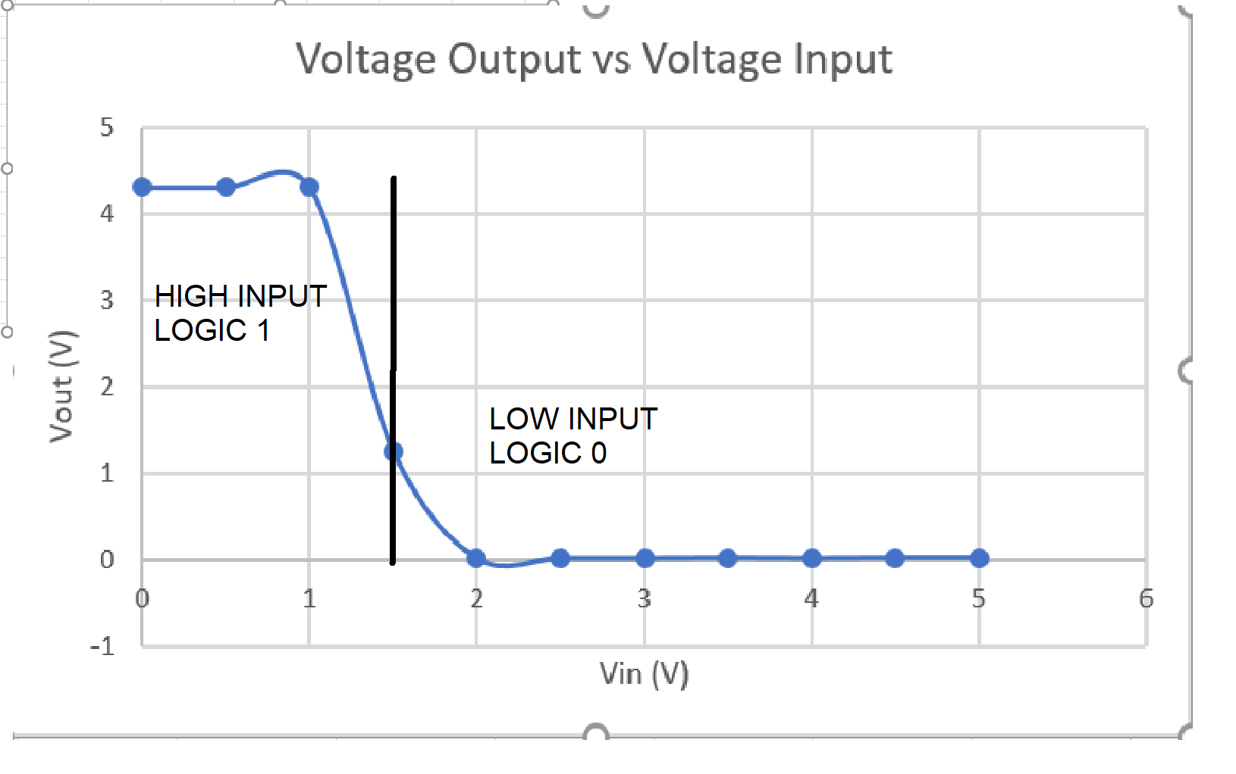

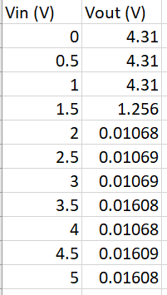

Voltage input vs Voltage output data table.

The high/low inputs and outputs are labeled on the graph. The high inputs outcome was low outputs and the low inputs outcome was high outputs. This further proves the characteristics of the inverter gate.

For second part of the lab, I tracked the circuit delay over a five ­inverter relay. This introduced us to clock signals, which can be modelled by using their period and frequency. For my ring oscillator the time was 61.3 ns and the frequency was 16.33 MHz. The oscilloscope graphed the output from the relay is shown below:

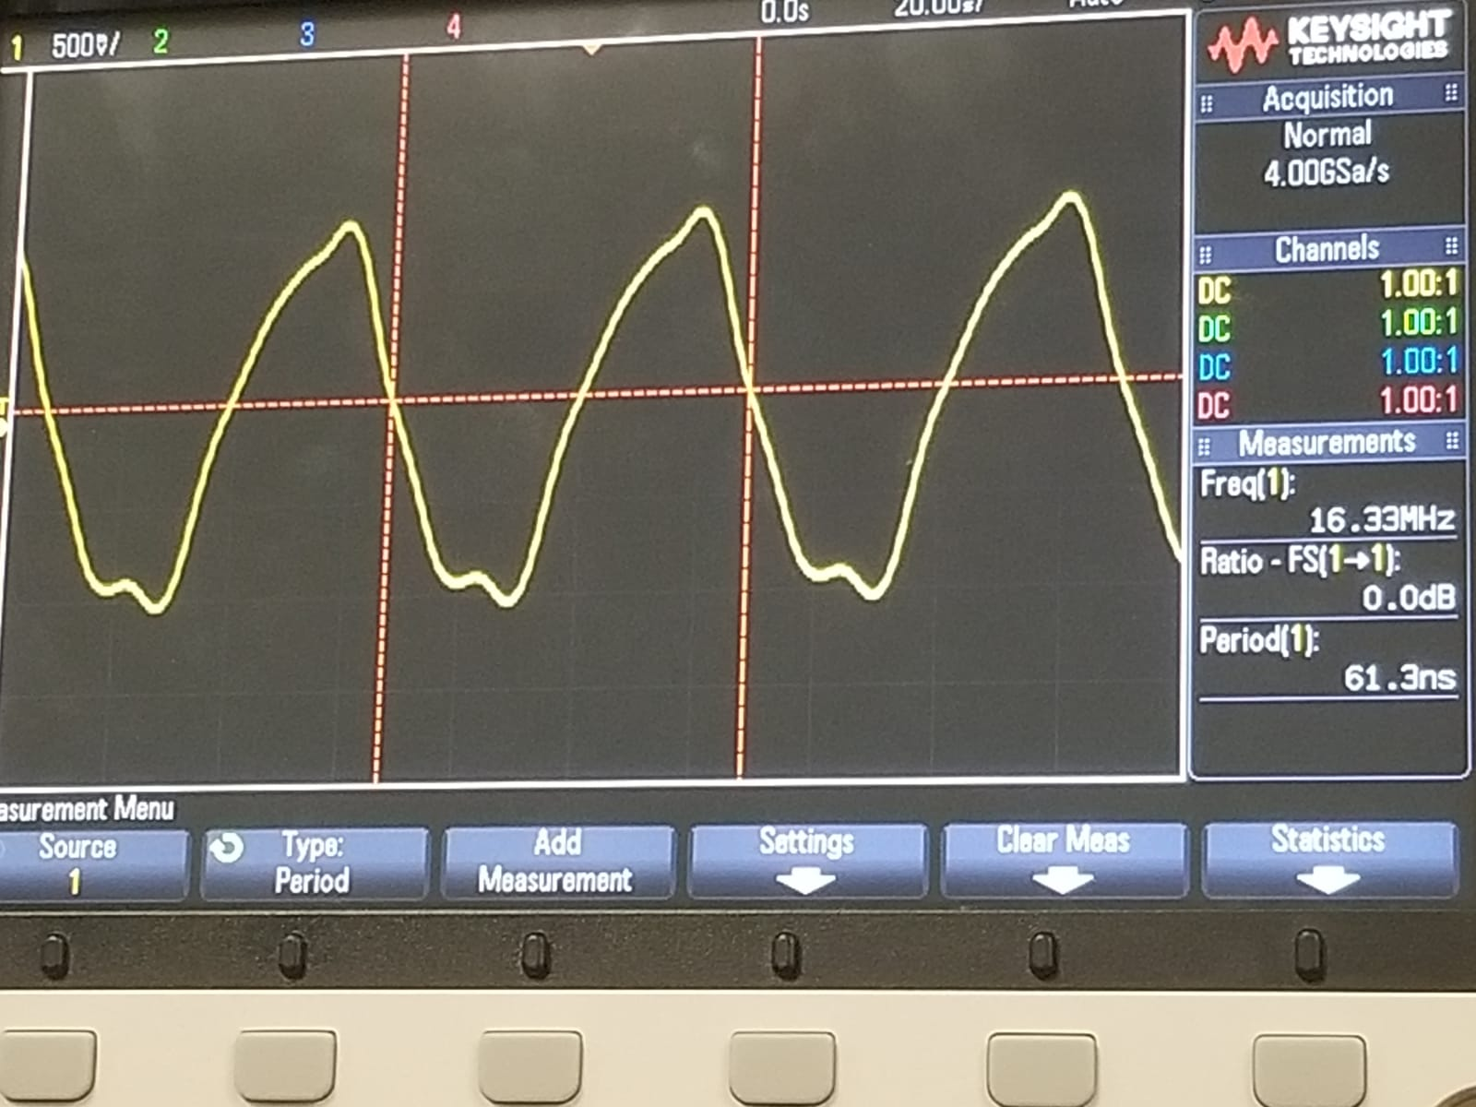

**Conclusion –**

In this lab, I measured the voltage output compared to the voltage input in an inverter gate to see the change in real time. Then I created a ring oscillator using an odd number of inverter gates. These experiments were incredibly interesting because they proved that electricity does not move instantaneously quickly. Learning that changes don’t happen immediately in this lab will be greatly beneficial for future labs as it shows that we cannot expect changes to happen immediately without any modifications to the delays. Even though the delay of 6.31 ns is fast, but if we have thousands of different gates all linking together, that number may increase rapidly.

**Questions –**

1. **Derive the single­stage delay of the Ring Oscillator from the time period of oscillation that you see in Experiment 2. If the delay of one inverter is 10ns, what will be the frequency of the signal generated from a 21 stage ring oscillator?**

The formula for Delay is T = 2* N* D, where T is the period and N is number of Gates used. So, for my experiment:

63.1 ns = 2 * 5 * Delay =

63.1 ns = 10 * Delay =

6.31 ns.

The formula for frequency is f =1/T. so if we had 21 gates and a delay of 10ns then the frequency will be 23.81 as the calculation is shown below.

f = 1/ T and T = 2 * N * D

T = 2 * 21 * 10 * 10^-9

T = 420ns

f=1/T = 1/ 420 = 23.81 MHz

1. **Are the signals at P, Q, R, S in Figure 2 periodic? If so, what are their time periods? How do these signals differ from the signal at node A?**

Yes, P, Q, R, and S are periodic. The time periods of P,Q,R, S are equal to the time period of the total system divided by 10. These signals differe from the signal at node A in that each of their output signals reverse the previous signal, so A’s output signal is equivalent to Q’s and S’s, but opposite from P’s and R’s.